Solid Geometry - Types of Solids - Convexity Solids - Convex Hull

Definition
# Source: AI Source: Provided by: [Data Path: Persons Table -> ID Column: 1, Name_En Column: Motasem Essam] -> From: [ChatGPT] on [7/25/2026]
The convex hull of a geometric object or set of points is the smallest convex set that contains the entire object or all the given points.
In three-dimensional geometry, the convex hull forms the smallest convex solid region that completely encloses a given collection of points or a non-convex solid.
It can be imagined as stretching a tight rubber sheet around an object: the sheet forms the object's convex hull, filling its inward indentations and spanning across its gaps.
A convex hull may be a polyhedron, a curved solid, or another convex three-dimensional shape, depending on the original object.

Geometric Representation
# Source: AI Source: Provided by: [Data Path: Persons Table -> ID Column: 1, Name_En Column: Motasem Essam] -> From: [ChatGPT] on [7/25/2026]
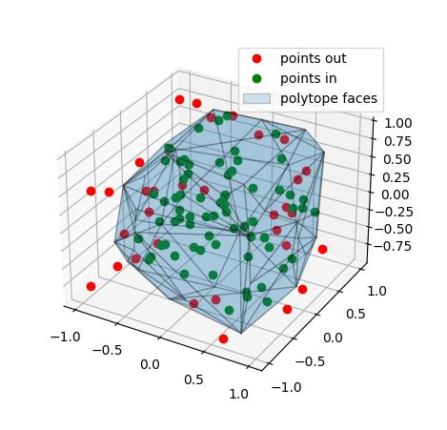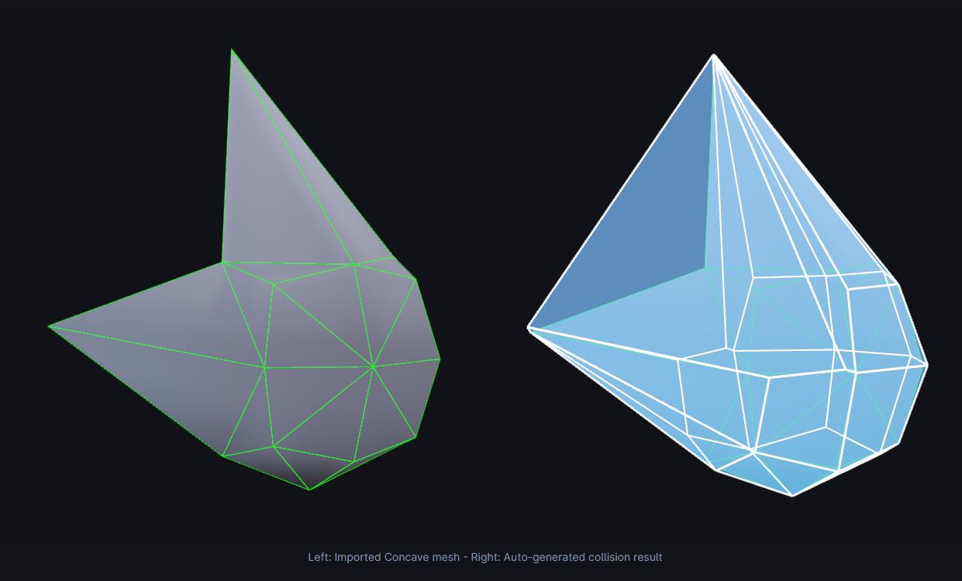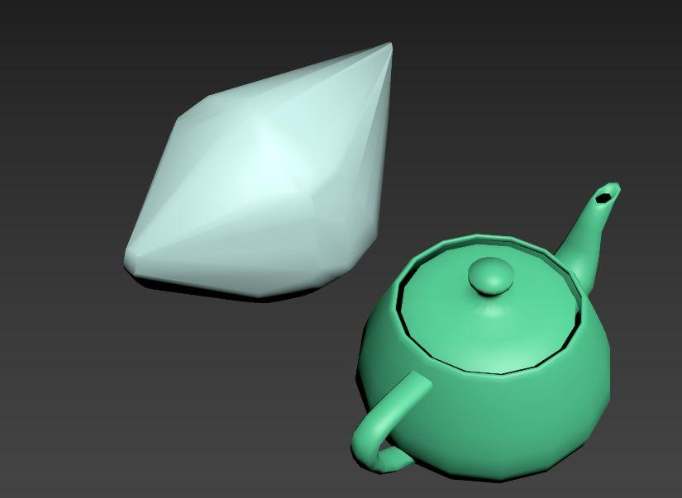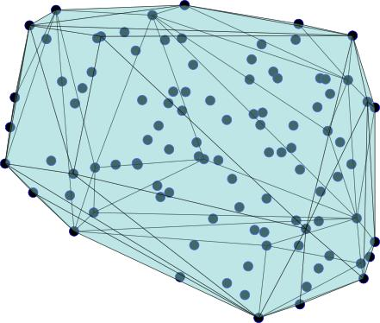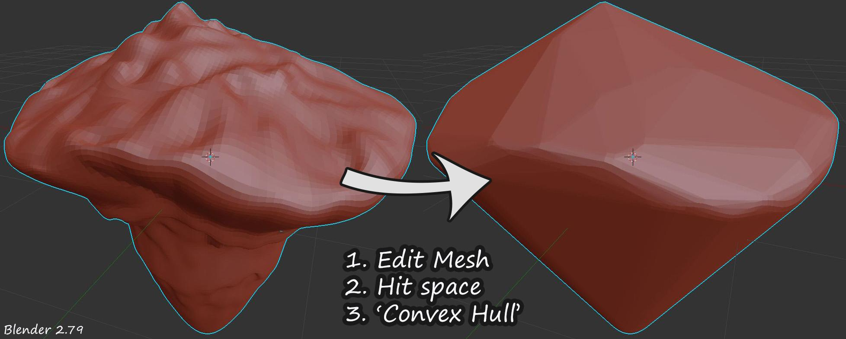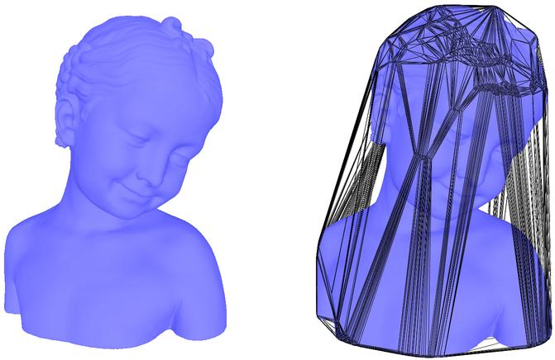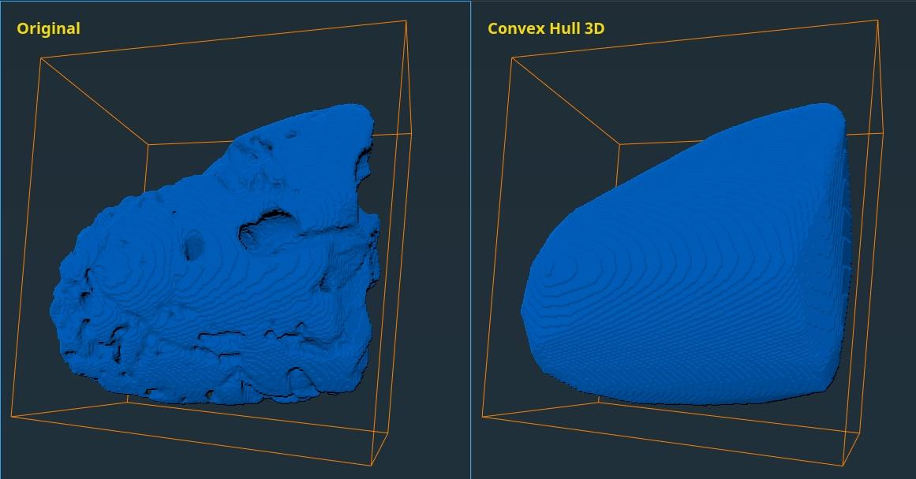

Geometric Structure
# Source: AI Source: Provided by: [Data Path: Persons Table -> ID Column: 1, Name_En Column: Motasem Essam] -> From: [ChatGPT] on [7/25/2026]
A convex hull has the following characteristics:
- Convex Boundary: Its boundary encloses a convex region.
- Complete Enclosure: It contains every point of the original object.
- Filled Indentations: Inward recesses and concave regions are filled or spanned over.
- Minimality: No smaller convex set can contain the entire original object.
- Convexity: Every line segment connecting two points in the hull remains inside the hull.

Mathematical Definition
# Source: AI Source: Provided by: [Data Path: Persons Table -> ID Column: 1, Name_En Column: Motasem Essam] -> From: [ChatGPT] on [7/25/2026]
Let $S$ be a set of points in three-dimensional space. Its convex hull is denoted by:
$$\boxed{Conv(S)}$$
It is defined as the intersection of all convex sets containing $S$:
$$Conv(S)=\bigcap_{\begin{aligned}C⊇S \\ C\text{ convex}\end{aligned}}{C}$$
Equivalently, it is the set of all possible convex combinations of points belonging to $S$:
$$Conv(S)=\left\{\sum_{i=1}^{n}{λ_{i}P_{i}} | P_{i}∈S, λ_{i}≥0, \sum_{i=1}^{n}{λ_{i}}=1\right\}$$
Here:
- $P_{i}$ represents a point in the original set.
- $λ_{i}$ represents a non-negative coefficient.
- The sum of all coefficients must equal 1.

Types of Convex Hulls in Three-Dimensional Geometry

Convex Hull of a Point Set
# Source: AI Source: Provided by: [Data Path: Persons Table -> ID Column: 1, Name_En Column: Motasem Essam] -> From: [ChatGPT] on [7/25/2026]
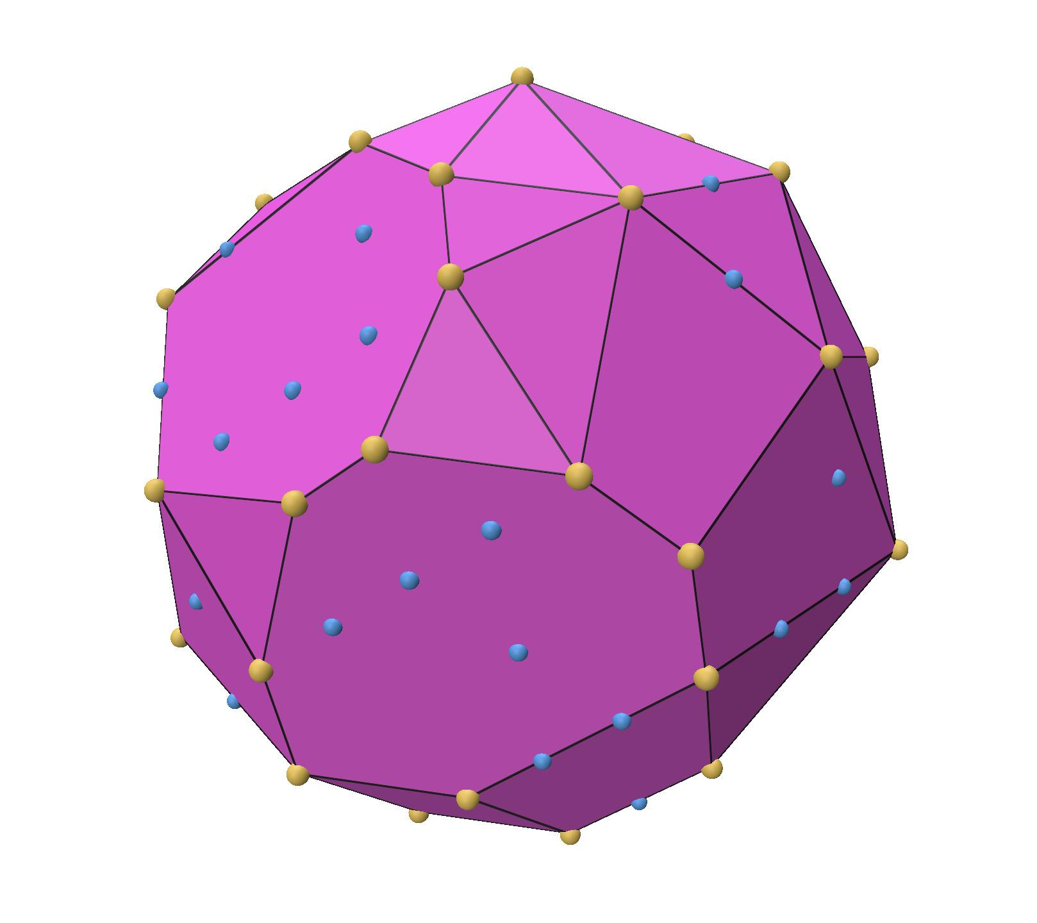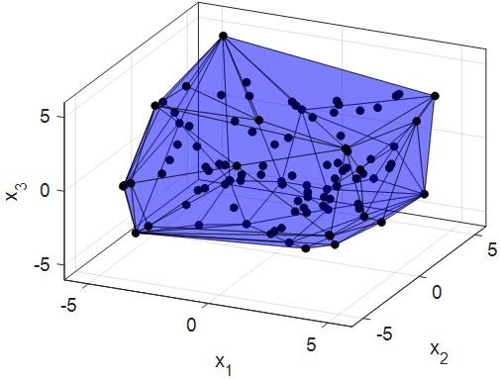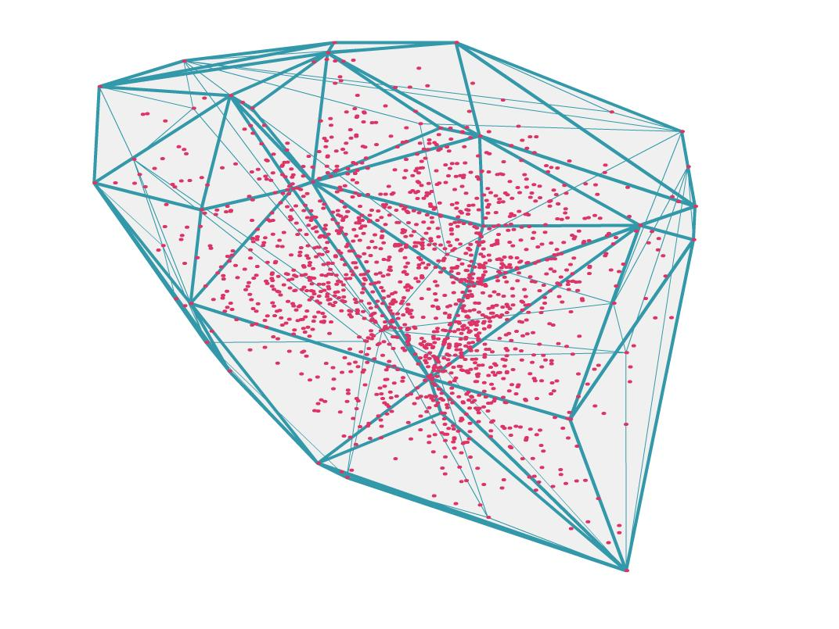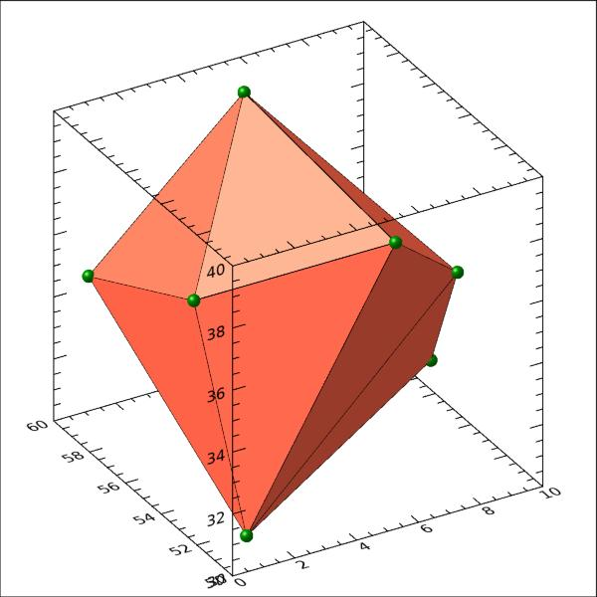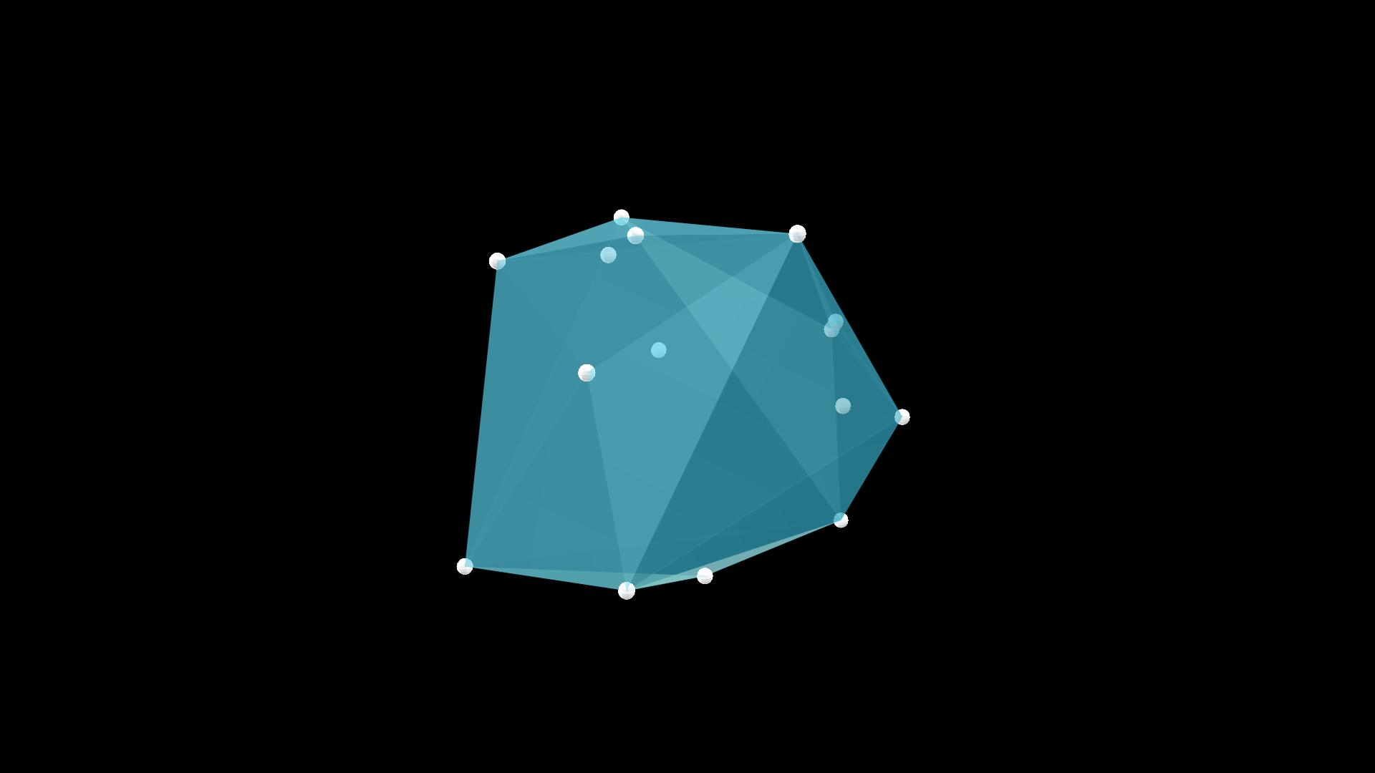
The convex hull of a finite collection of points is the smallest convex polyhedron containing all those points, provided that the points span three-dimensional space.
Its vertices are selected from the original point set. Points lying strictly inside the hull do not contribute vertices.

Convex Hull of a Solid
# Source: AI Source: Provided by: [Data Path: Persons Table -> ID Column: 1, Name_En Column: Motasem Essam] -> From: [ChatGPT] on [7/25/2026]
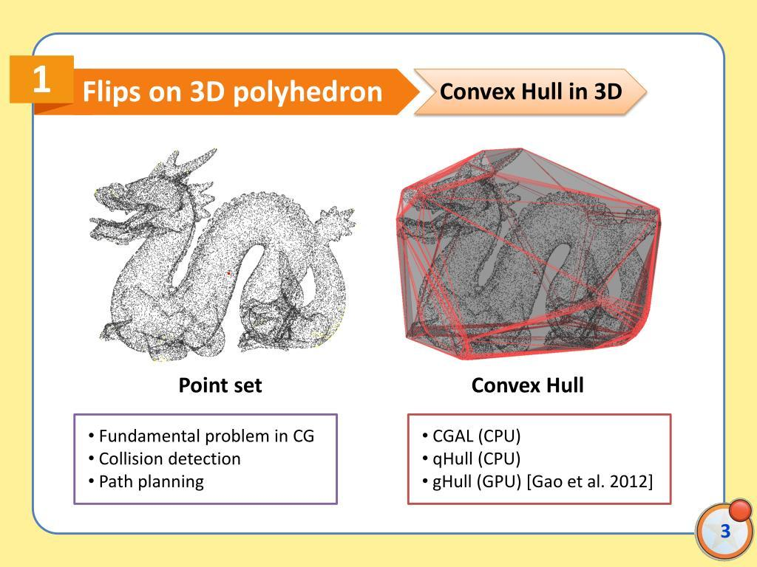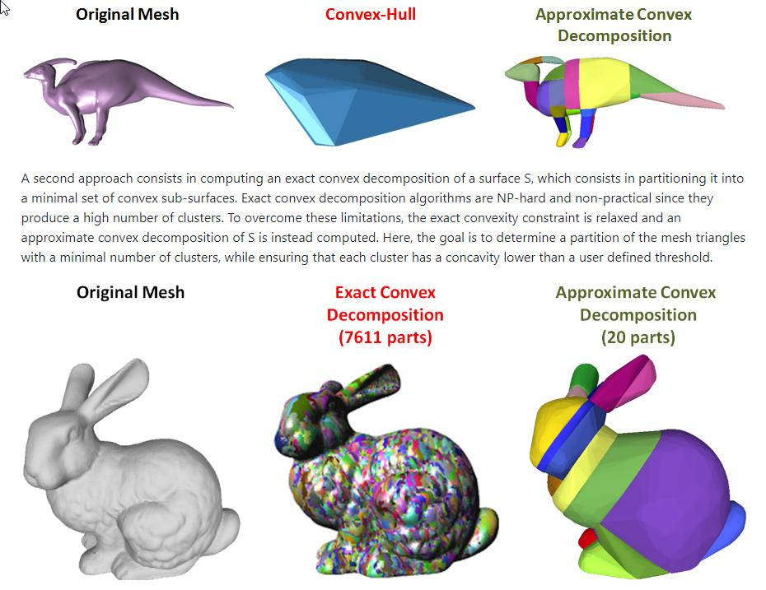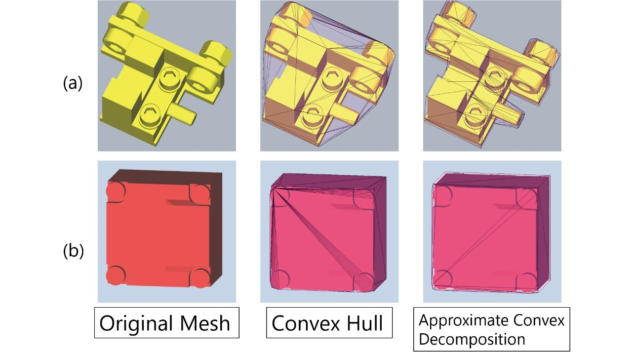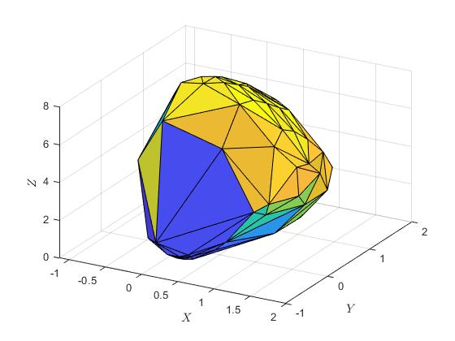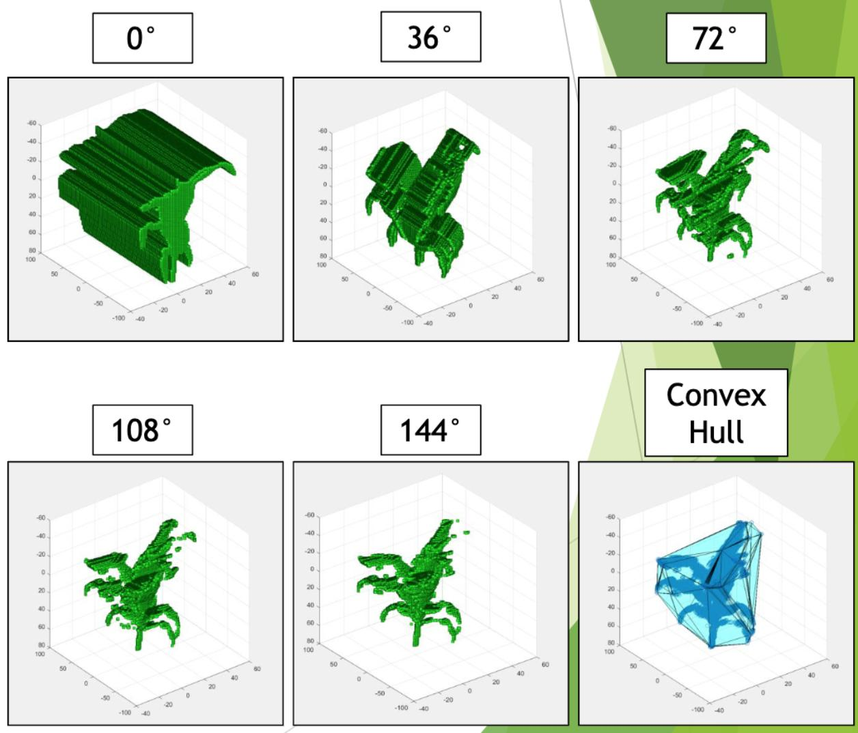
The convex hull of a solid is the smallest convex solid that contains the entire original solid.
It fills or spans its concave regions, producing a convex enclosing shape.
Examples:
- Convex hull of an L-shaped solid.
- Convex hull of a U-shaped solid.
- Convex hull of a concave polyhedron.
- Convex hull of an irregular composite solid.

Convex Hull of a Surface
# Source: AI Source: Provided by: [Data Path: Persons Table -> ID Column: 1, Name_En Column: Motasem Essam] -> From: [ChatGPT] on [7/25/2026]
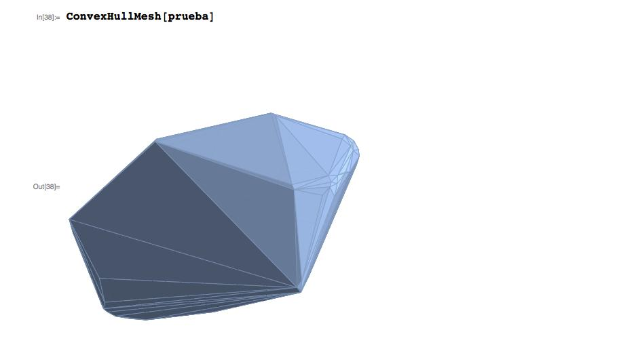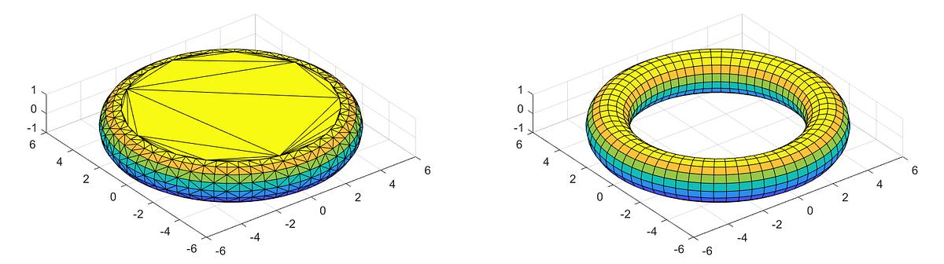
The convex hull of a surface is the smallest convex region containing every point on that surface.
For example, the convex hull of a toroidal surface encloses the entire torus, including its central opening.
Important: A surface and the solid enclosed by that surface are different geometric objects. Their convex hulls should be defined using the actual points included in each object.

Geometric Properties
# Source: AI Source: Provided by: [Data Path: Persons Table -> ID Column: 1, Name_En Column: Motasem Essam] -> From: [ChatGPT] on [7/25/2026]
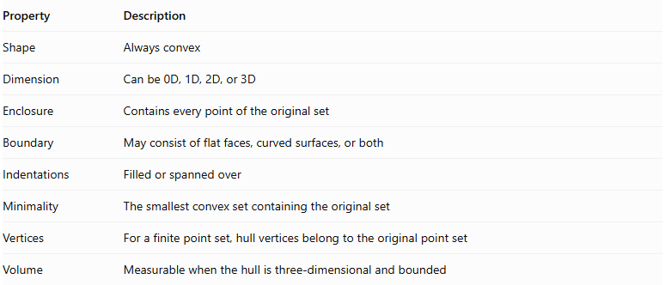
Property | Description
Shape | Always convex
Dimension | Can be 0D, 1D, 2D, or 3D
Enclosure | Contains every point of the original set
Boundary | May consist of flat faces, curved surfaces, or both
Indentations | Filled or spanned over
Minimality | The smallest convex set containing the original set
Vertices | For a finite point set, hull vertices belong to the original point set
Volume | Measurable when the hull is three-dimensional and bounded

Mathematical Properties and Theorems

Convexity
# Source: AI Source: Provided by: [Data Path: Persons Table -> ID Column: 1, Name_En Column: Motasem Essam] -> From: [ChatGPT] on [7/25/2026]
The convex hull is always convex.
For any two points $P,Q$ belonging to the convex hull:
$$P,Q∈Conv(S)$$
Then:
$$(1-t)P+tQ∈Conv(S)$$
for every:
$$0≤t≤1$$

Containment
# Source: AI Source: Provided by: [Data Path: Persons Table -> ID Column: 1, Name_En Column: Motasem Essam] -> From: [ChatGPT] on [7/25/2026]
The convex hull always contains the original set:
$$\boxed{S⊆Conv(S)}$$

Idempotence
# Source: AI Source: Provided by: [Data Path: Persons Table -> ID Column: 1, Name_En Column: Motasem Essam] -> From: [ChatGPT] on [7/25/2026]
Taking the convex hull of an already convex hull does not change it:
$$\boxed{Conv(Conv(S))=Conv(S)}$$

Convex Set Property
# Source: AI Source: Provided by: [Data Path: Persons Table -> ID Column: 1, Name_En Column: Motasem Essam] -> From: [ChatGPT] on [7/25/2026]
If the original set is already convex, its convex hull is equal to the original set:
$$\boxed{Conv(S)=S}$$

Monotonicity
# Source: AI Source: Provided by: [Data Path: Persons Table -> ID Column: 1, Name_En Column: Motasem Essam] -> From: [ChatGPT] on [7/25/2026]
If one set is contained in another:
$$A⊆B$$
Then:
$$\boxed{Conv(A)⊆Conv(B)}$$

Carathéodory's Theorem
# Source: AI Source: Provided by: [Data Path: Persons Table -> ID Column: 1, Name_En Column: Motasem Essam] -> From: [ChatGPT] on [7/25/2026]
In three-dimensional space, every point belonging to the convex hull of a set can be represented as a convex combination of no more than four points from that set.
This means that four points are sufficient to represent any individual point inside a three-dimensional convex hull.

Volume and Surface Area
# Source: AI Source: Provided by: [Data Path: Persons Table -> ID Column: 1, Name_En Column: Motasem Essam] -> From: [ChatGPT] on [7/25/2026]
For a bounded three-dimensional solid $S$, its convex hull can be used to determine the additional space required to enclose the object in a convex shape.

Convex Hull Volume
# Source: AI Source: Provided by: [Data Path: Persons Table -> ID Column: 1, Name_En Column: Motasem Essam] -> From: [ChatGPT] on [7/25/2026]
$$V_{H}=Volume(Conv(S))$$

Original Solid Volume
# Source: AI Source: Provided by: [Data Path: Persons Table -> ID Column: 1, Name_En Column: Motasem Essam] -> From: [ChatGPT] on [7/25/2026]
$$V_{S}=Volume(S)$$

Additional Enclosed Volume
# Source: AI Source: Provided by: [Data Path: Persons Table -> ID Column: 1, Name_En Column: Motasem Essam] -> From: [ChatGPT] on [7/25/2026]
$$\boxed{V_{A}=V_{H}-V_{S}}$$
Where:
- $V_{H}$ = Convex hull volume.
- $V_{S}$ = Original solid volume.
- $V_{A}$ = Additional volume enclosed by the convex hull.
This volume represents the space added by filling or spanning the concave regions, assuming the original solid is contained in the hull.

Construction of a Three-Dimensional Convex Hull
# Source: AI Source: Provided by: [Data Path: Persons Table -> ID Column: 1, Name_En Column: Motasem Essam] -> From: [ChatGPT] on [7/25/2026]
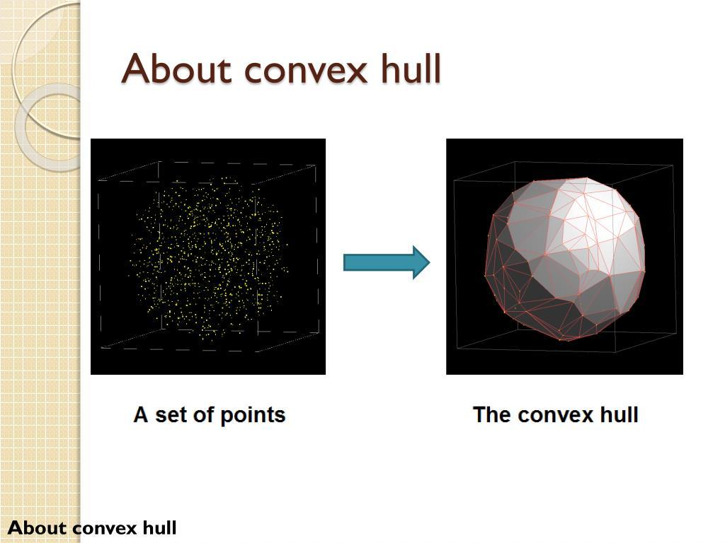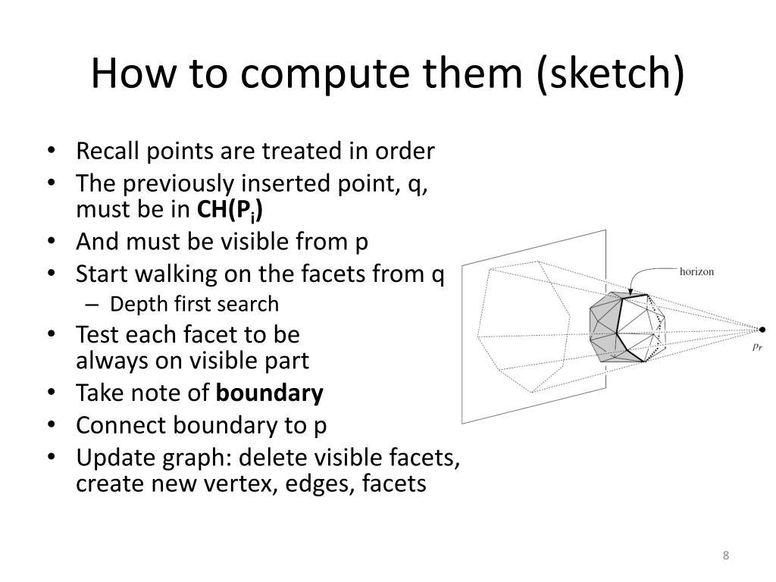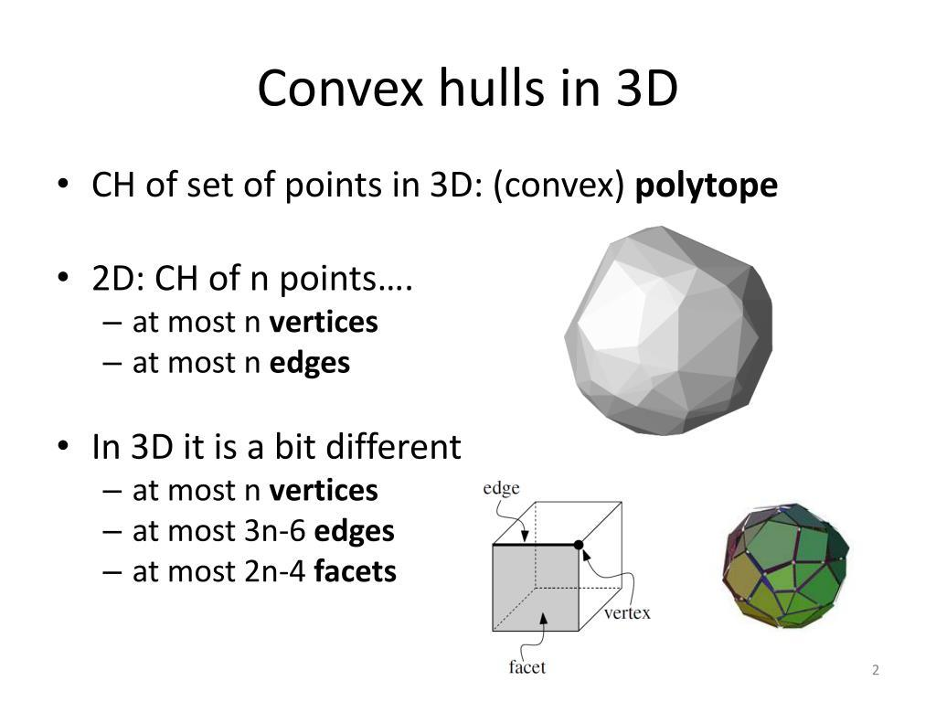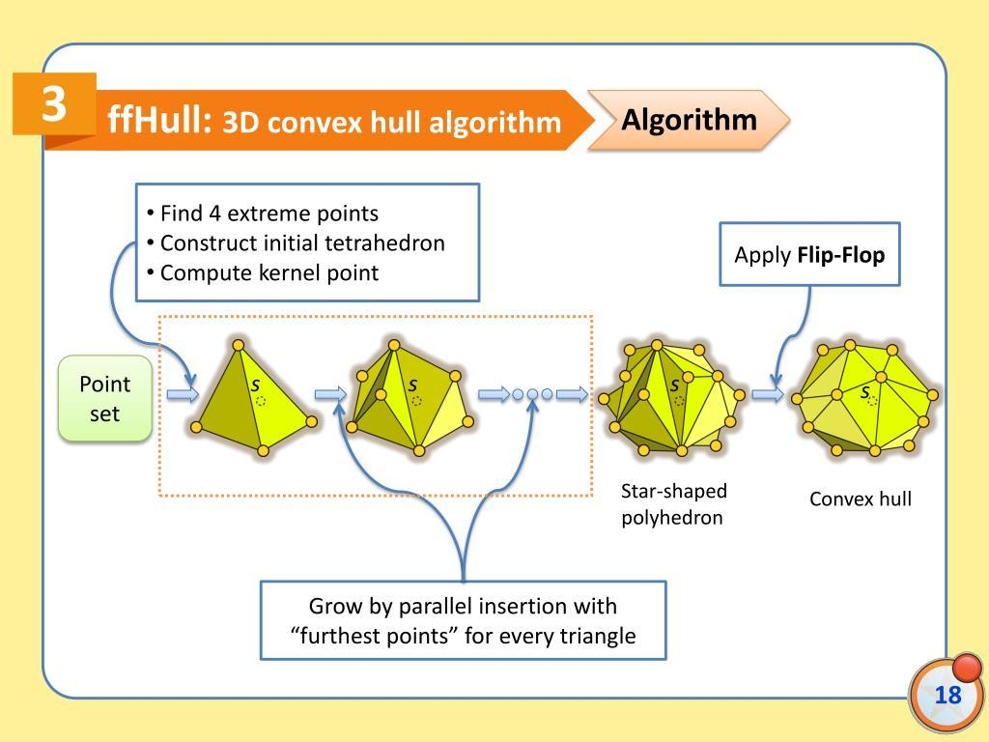
A convex hull of a finite set of three-dimensional points can be constructed using computational geometry algorithms.
General construction process:
- Point Collection: Identify all points that define the original geometric object.
- Extreme Point Identification: Determine points that may form the outer boundary.
- Boundary Construction: Connect the extreme points to form convex polygonal faces.
- Convexity Verification: Ensure that every line segment between points inside the resulting hull remains within it.
- Containment Verification: Confirm that every original point is inside or on the hull boundary.
The resulting structure is a convex polyhedron when the point set spans three-dimensional space.

Applications
# Source: AI Source: Provided by: [Data Path: Persons Table -> ID Column: 1, Name_En Column: Motasem Essam] -> From: [ChatGPT] on [7/25/2026]
- Computational Geometry: Determining the smallest convex enclosure of a point set.
- Computer Graphics: Generating simplified enclosing shapes for 3D models.
- Collision Detection: Creating bounding volumes for objects in simulations.
- 3D Modeling: Identifying the outermost geometric structure of an object.
- Robotics: Representing object boundaries and spatial regions.
- Geometric Analysis: Comparing a non-convex object with its convex enclosure.

Comparison with Related Concepts
# Source: AI Source: Provided by: [Data Path: Persons Table -> ID Column: 1, Name_En Column: Motasem Essam] -> From: [ChatGPT] on [7/25/2026]
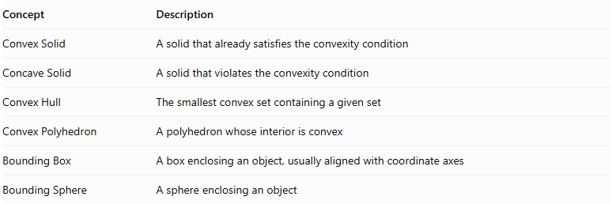
Concept | Description
Convex Solid | A solid that already satisfies the convexity condition
Concave Solid | A solid that violates the convexity condition
Convex Hull | The smallest convex set containing a given set
Convex Polyhedron | A polyhedron whose interior is convex
Bounding Box | A box enclosing an object, usually aligned with coordinate axes
Bounding Sphere | A sphere enclosing an object
A convex hull is not necessarily a box or sphere. It follows the outermost geometric arrangement of the original points or object.

Main Classification
# Source: AI Source: Provided by: [Data Path: Persons Table -> ID Column: 1, Name_En Column: Motasem Essam] -> From: [ChatGPT] on [7/25/2026]
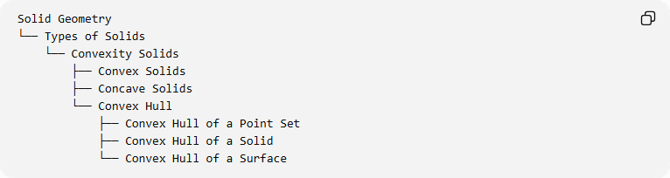
Solid Geometry
└── Types of Solids
└── Convexity Solids
├── Convex Solids
├── Concave Solids
└── Convex Hull
├── Convex Hull of a Point Set
├── Convex Hull of a Solid
└── Convex Hull of a Surface

Key Points
# Source: AI Source: Provided by: [Data Path: Persons Table -> ID Column: 1, Name_En Column: Motasem Essam] -> From: [ChatGPT] on [7/25/2026]
- The convex hull is the smallest convex set containing a given set of points or geometric object.
- It always satisfies the mathematical condition of convexity.
- It fills or spans inward indentations and concave regions.
- The convex hull of a finite three-dimensional point set is a convex polyhedron if the points span three dimensions.
- The convex hull of an already convex set is the set itself.
- Its volume is never smaller than the volume of the original bounded solid.

Conclusion
# Source: AI Source: Provided by: [Data Path: Persons Table -> ID Column: 1, Name_En Column: Motasem Essam] -> From: [ChatGPT] on [7/25/2026]
The Convex Hull is a fundamental concept in convex geometry that transforms any given set of points or geometric object into its smallest convex enclosing region. In solid geometry, it provides a way to represent concave solids through convex shapes and is widely used in geometric modeling, computational geometry, and spatial analysis.

